**Project Design Phase-II**

**Data Flow Diagram & User Stories**

| Date | 31 January 2025 |
| --- | --- |
| Team ID | SWTID1743511769 |
| Project Name | TravelSphere(Social media for travel enthusiast) |
| Maximum Marks | 4 Marks |

**Data Flow Diagrams:**

### Entities:

* **Customer (Web/Mobile)** → The user who books trips or travel services.
* **Admin** → The person managing packages, destinations, bookings, and users.
* **Payment Gateway** → Handles secure transactions for bookings.
* **Email Service** → Sends booking confirmations, itineraries, and notifications.

### Process:

* **TravelSphere Booking System**

### Data Stores:

* **User Database** → Stores customer details, login info.
* **Travel Package Catalog** → Contains all trip packages, destinations, prices, etc.
* **Booking Database** → Stores travel bookings and statuses.
* **Payment Records** → Stores payment history and invoice details.

### Basic Flow:

* Customer → Registers/Logs In → TravelSphere Booking System
* Customer → Browses Packages / Selects Destination → Travel Package Catalog
* Customer → Books a Trip → Booking Database
* System → Sends Confirmation / Itinerary → Email Service
* Customer → Makes Payment → Payment Gateway → Payment Records
* Admin → Manages Users / Packages / Bookings → User DB & Travel Package Catalog

**Level 0 DFD:**

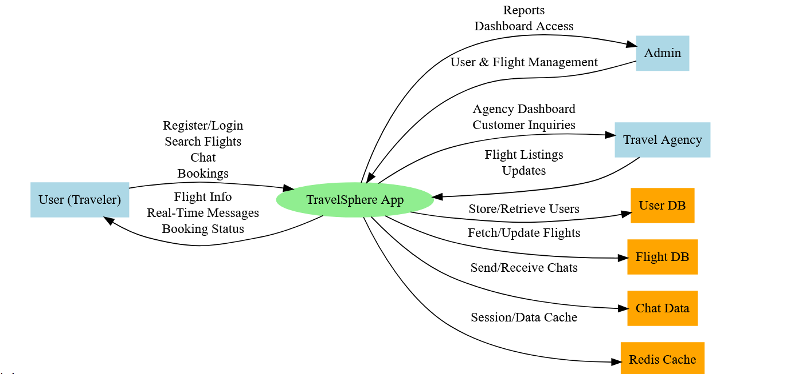

**User Stories**

| **User Type** | **Functional Requirement (Epic)** | **User Story Number** | **User Story / Task** | **Acceptance criteria** | **Priority** | **Release** |
| --- | --- | --- | --- | --- | --- | --- |
| Customer (Mobile user) | Registration | USN-1 | As a user, I can register for the application by entering my email, password, and confirming my password. | I can access my account / dashboard | High | Sprint-1 |
| Customer (Mobile user) | Registration | USN-2 | As a user, I will receive confirmation email once I have registered for the application | I can receive confirmation email & click confirm | High | Sprint-1 |
| Customer (Mobile user) | Registration | USN-3 | As a user, I can register for the application through Facebook | I can register & access the dashboard with Facebook Login | Low | Sprint-2 |
| Customer (Mobile user) | Registration | USN-4 | As a user, I can register for the application through Gmail | I can see the homepage/dashboard | Medium | Sprint-1 |
| Customer (Mobile user) | Login | USN-5 | As a user, I can log into the application by entering email & password | I can see the homepage/dashboard | High | Sprint-1 |
| Customer (Mobile user) | Explore Packages | USN-6 | As a user, I can view travel packages categorized by destination or type (beach, adventure, etc.). | Categories with travel packages are displayed | High | Sprint-2 |
| Customer (Web user) | Search & Filter | USN-7 | As a user, I can search and filter travel packages | Filtered results match search keywords or criteria | Medium | Sprint-3 |
| Customer Care Executive | Booking | USN-8 | As a user, I can book a travel package and receive a confirmation. | Confirmation screen shown after booking/payment | High | Sprint-3 |
| Customer (Mobile user) | Chat | USN-9 | As a user, I can chat with a travel support agent for queries. | Chat history is visible unless manually deleted | Medium | Sprint-4 |
|  | User Support | USN-10 | As a care executive, I can view and respond to support queries. | Ticket system shows queries and allows reply | High | Sprint-1 |
| Admin | Package Management | USN-11 | As an admin, I can add, edit, and delete travel package details. | Travel package listing is updated in real-time | High | Sprint-2 |
| Admin | User Management | USN-12 | As an admin, I can view all registered users and block/unblock them. | Changes take effect immediately | High | Sprint-3 |